Name of Research Project: An examination of human driver preferences of two different automated vehicle control algorithms, assisting drivers to take over vehicle control in mixed platoon settings. .
Research Protocol:
Goals:
This study will use the CoppeliaSim driving simulator to examine the driver's performance and subjective preferences for two different automated driving control algorithms:
- An algorithm that has joint control with the human driver on the vehicle's acceleration and intervenes (increases acceleration or deacceleration) based on the driver's performance and the algorithm's mathematical module.

- An algorithm that generates a larger distance between the human driver and the vehicle ahead in the platoon. Such an intervention is expected to enable better driving conditions for a human driver to break out of the mixed platoon. Due to the time interval between the moment when the driver initiated a take over request and the driving conditions allowing to perform the takeover, the algorithm has two operation modes that will be evaluated based on the driver's preferences:
- Fast mode: In this configuration, the acceleration will be high. Therefore, it will not take long to reach the required driving conditions (required gap) but might create discomfort for the driver
- Slow Mode: In this configuration, changes in the acceleration will be slower. Thus, it will take more time to reach the required driving conditions. On the one hand, the driver may be impatient, but on the other hand, may feel safer driving in the platoon.
Specifically, the comparison of the two algorithms will be based on performance data, including vehicle dynamics (acceleration, braking, gap between the cars) and subjective measurement that include various questionnaires.
The experiment will be conducted in the mechanical engineering department at Dr. Shai Arogeti's lab in building 57 at BGU.
Participants:
The study will be carried out on approximately 15-20 participants with at least 5 years of driving experience.
Based on their subjective report, participants will have normal or corrected-to-normal visual acuity of 6/9 or better. Participants will be recruited by word-of-mouth from amongst friends and colleagues of the experimenter. Participation in this, half to one hour long study, is voluntary and without any compensation (as is stated in the participant Consent form).
Tools:
PC-based driving simulator: The desktop driving simulator at BGU is located at the Mechanical Engineering Department and includes curved 27" LCDs. In addition, the driving simulator consists of a Logitech steering wheel and pedals (only the pedals will be used, whilst the steering wheel will help the "realistic feeling") and a gamer seat that resembles a car seat.
The driving simulation software and the virtual environments are the open-source driving simulator CoppeliaSim. The map was built using MathWorks's RoadRunner (see the interface in Fig1)
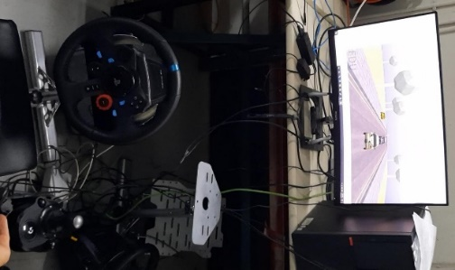
Fig1. PC-based driving simulator (CoppeliaSim) User Interface & Logitech steering wheel and pedals

Experimental Design:
The proposed study will include a within-subjects design. Each participant will experience driving under both vehicle control algorithms in two consecutive sessions:
- Half of the participants will first experience the car assistant (joint control) driving condition followed by the car switch driving condition (divided into two algorithems, the fast and the slow one, as explained above).
- The other half will experience the two driving conditions in the opposite order.
In each session, drivers will be asked to keep driving in the platoon under autonomous until they feel they have fully acclimatized to the driving environment and can track a car in front approximately at a constant time headway.
Then, after notifying the experimenter that they are comfortable to proceed, the experimenter will start the simulation where the car will be a part of an autonomous platoon. After a few seconds, the participants will be asked to switch to manual driving mode and complete one or two minutes driving manually. This will repit itself 2-3 times for each algorithem (therefore the simulation will run 6-9 times in totle without the training run). When the simuation will rub the acceleration, velocity and gap (change in gap and etc) will be recorded.
After the 4th session ( [1]. training [2] first method, [3] 2nd method- fast one,[4] 2nd method- slow method), participants will be asked to complete a questionnaire about their feelings and confidence towards the driving. During each session, vehicle dynamics data will be recorded for each participant. This data includes velocity, acceleration, braking, and time (and distance) headway between the participant's vehicle and the lead vehicle.

Procedure:
- When the participant arrives at the lab, the experimenter will verify that the participant has normal or corrected to normal visual acuity. If the participant uses glasses when sitting in front of a computer screen, they will be asked to wear them during the experiment.
- The participant will read and sign the Consent form.
- The participant will be asked to read the experiment's instructions (see Appendix I) and ask the experimenter for clarifications where needed.
- The participant is now ready for a driving session.
BEFORE the first driving session, the participant will fill in a demographics questionnaire (See Appendix II)
- The participant will begin driving the first session depending on the order to which he or she were assigned.
- After completing the first session, the participant will begin the second session.
- At the end of the second session, the participant will fill a self-developed questionnaire comparing the two sessions (See Appendix III).
- The participant will be thanked for his or her participation and will leave the lab.

Data Security & Disclosure:
- All data collected in the study will be saved in a locked computer at the driving simulator lab (the lab has an alarm with a code known only to the research team).

- Each participant will receive a number that is dissociated from the identifying details that appear on the Consent form. This number will be used for the driving simulator files and the questionnaires. The consent forms will be saved in a locked cabinet in the driving simulator lab. Only the research team will be able to connect identifying details of the participant with performance data. Any future publication of this study will never include identifying details of a participants. Future publications will only include aggregated data.

References:
- Hussein Dia, An agent-based approach to modelling driver route choicebehaviour under the influence of real-time information, Department of Civil Engineering, The University of Queensland, Brisbane, Qld 4072, Australia, 2002

- Niek Mouter , Sander Van Cranenburgh Do individuals have different preferences as consumer and citizen? The trade-off between travel time and safety, Delft University of Technology, December 2017

- Kristin Mühl* , Christoph Strauch* , Christoph Grabmaier, Susanne Reithinger, Anke Huckauf, and Martin Baumann, "Get Ready for Being Chauffeured: Passenger’s Preferences and Trust While Being Driven by Human and Automation "Ulm University, Germany, sep 2019

Appendices:
I. Instructions
A printed copy of the Instructions will be provided to each participant when they arrive)
אנא אשר את טופס הסכמה לניסוי

- אנא מלא את השאלון הקצר

- בדקות הקרובות תתבקש לנהוג בסימולטור כדי להרגיש בנוח בנהיגה בסימולטור. התפקיד שלך זה לנהוג בסימולטור( בשימוש בגז ובברקס) כאילו זה העולם האמיתי. אנא נהג כמה שאתה צריך עד שאתה מרגיש בנוח עם הסביבה ועם רמת הנהיגה שלך

- נסה לשמור על מרחק אחיד מהרכב שלפניך כסימן שאתה שלוט בתאוצה ומהירות הרכב כשאתה מרגיש בנוח עם הסימולטור אנא יידע את הניסיין והוא יאתחל את הסימולטור עם השיירת רכבים.

- אחרי שהסימולציה תתחיל תתבקש לעבור למצב נהיגה ידני, לחץ כשאתה מרגיש בנוח
- אם זה הבקרה המשולבת אנא התנהג שהשליטה בידיים שלך בצורה מידיית
- אם זה המעבר שליטה, חכה להודעה שאתה יכול לקחת שליטה

- הנסיין יודיע לך כשאתה צריך להפסיק את הסמולטר, לאחר מכן אנא מלא את השאלון.

II. Demographics Questionnaire to complete BEFORE the session
Since all of the participants are expected to speak Hebrew, the questionnaires will be in Hebrew.
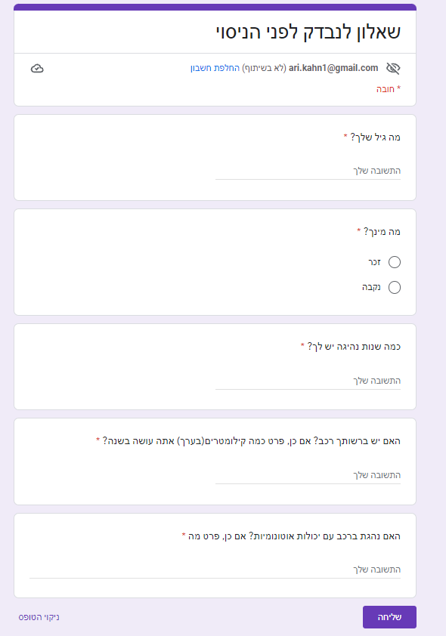

III. Questionnaire to complete AFTER the session
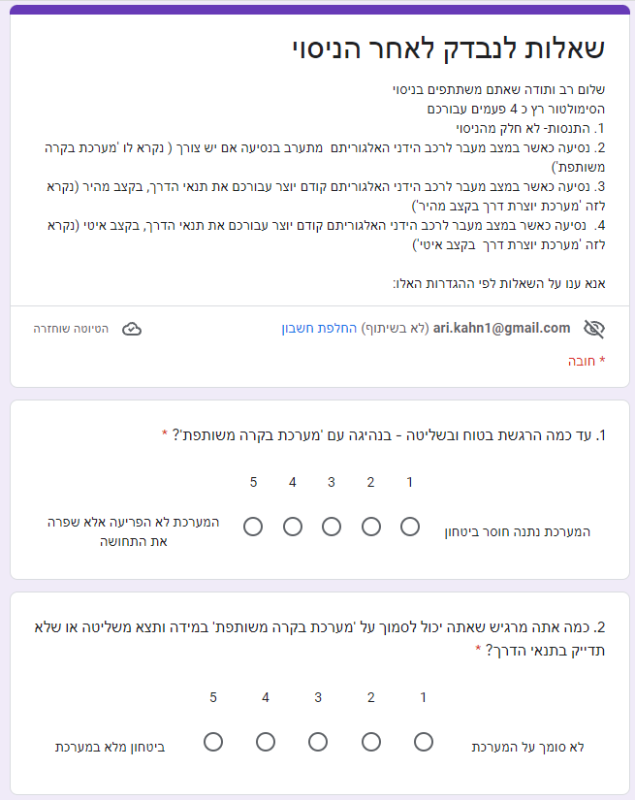
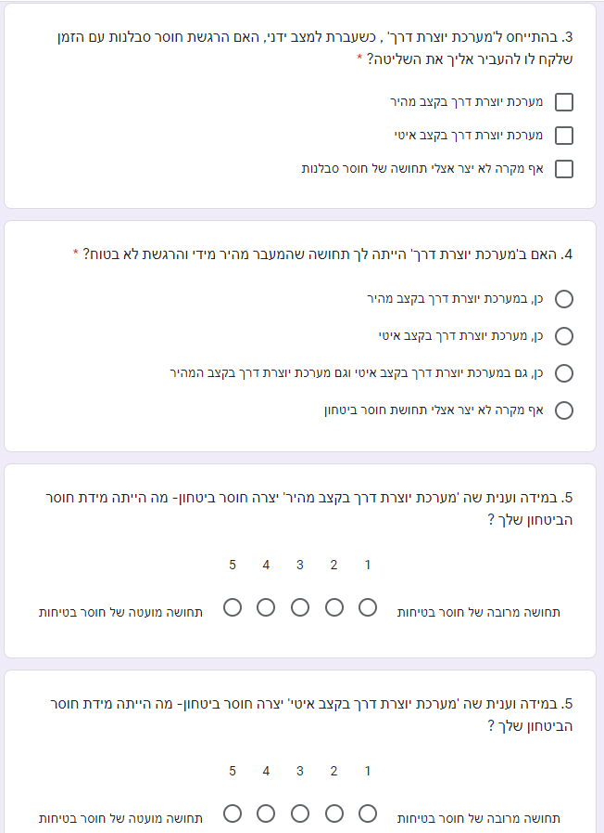

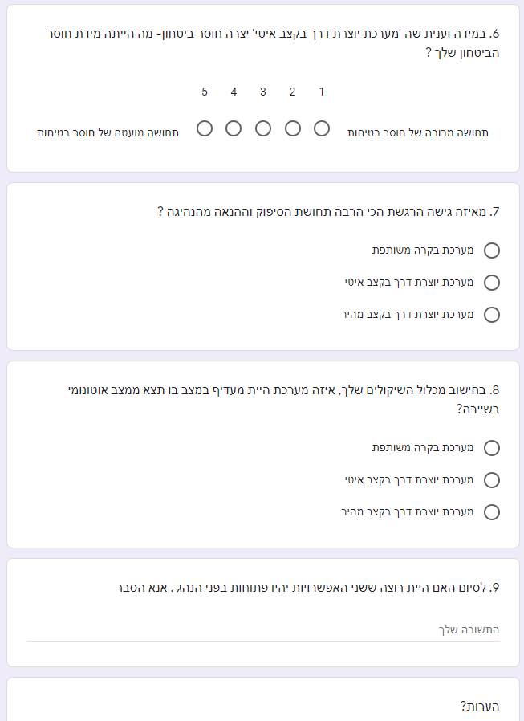

IV. Consent Form
(To be completed by participants on arrival)

Consent Form

Principal Investigators:

Avinoam Borowsky
PhD Industrial Engineering and Management Dept.
Ben Gurion University of the Negev

Shai Arogeti,
PhD Mechanical Engineering Dept.
Ben Gurion University of the Negev.

You are invited to participate in a study conducted by the Ben Gurion University of the Negev.
The purpose of this study is to improve traffic safety – your participation answers will help us do this.

If you agree to be part of the study, you will drive a PC based driving simulator at Dr Arogeti's lab.
The experiment takes about half an hour during which you will also be asked to complete questionnaires.
Signing this form means that you consent to participate in procedures described above.

NOTE:
- We will not collect any identifying details about you.
- The only data we collect includes data from the driving simulator and answers to the questionnaire – this data that cannot be linked to any identifying details about you.
- No person outside the research team will have any access to your information.
- Your identity will not be revealed in any publication resulting from this study.

Also note that your participation in this study is voluntary, so that even if you sign this consent form, you may choose to stop driving and/or not answer any questionnaire at any time, and you may withdraw your consent to participate at any time. Should you decide not to participate or to withdraw from the study, this will not have any consequences for you.

There is no compensation for participation in this study - your answers will help us improve traffic safety.

If you have any questions or concerns about this study or if any problems arise, please contact: Dr Avinoam Borowsky at 052-3321862

I understand the information presented in this document, and I had the opportunity to ask questions and receive answers from the investigator.

NOTE: This Consent form is the only form that includes your name (NOT your ID number).
To assure extra security you will be assigned an arbitrary subject number that will be used in the collection of data.

I AGREE TO VOLUNTARILY PARTICIPATE IN THE STUDY:

Name: Participant Signature Date

______________ ______________ _________

Name: Experimenter Signature Date

Aryeh Kahn ___________ _________

I understand the information presented in this document, and I had the opportunity to ask questions and receive answers from the investigator.
BY SIGNING THIS FORM, I VOLUNRARILY AGREE TO PARTICIPATE IN
THE STUDY

Name of Participant Signature Date

______________ ______________ ______________

Name of Experimenter Signature Date

Aryeh Kahn ________ ______________

טופס ההסכמה נכתב בלשון זכר, אך מופנה לזכר ונקבה כאחד:

חוקרים ראשיים:

ד"ר אבינועם בורובסקי
מהמחלקה להנדסת תעשייה וניהול
אוניברסיטת בן גוריון בנגב

ד"ר שי ארוגטי,
מהמחלקה להנדסת מכונות
אוניברסיטת בן גוריון בנגב.

הנכם מוזמנים להשתתף במחקר שערכה אוניברסיטת בן גוריון בנגב.
מטרת המחקר היא לשפר את בטיחות הדרכים ויעילותו - תשובות ההשתתפות שלך יעזרו לנו לעשות זאת.

אם תסכימו להיות חלק מהמחקר, תנהגו בסימולטור נהיגה מבוסס PC במעבדה של ד"ר ארוגטי.
הניסוי אורך כחצי שעה במהלכה תתבקשו גם למלא שאלונים.
חתימה על טופס זה פירושה שאתה מסכים להשתתף בהליכים המתוארים לעיל.

הערה:
• לא נאסוף עליך פרטים מזהים.
• הנתונים היחידים שאנו אוספים כוללים נתונים מסימולטור הנהיגה ותשובות לשאלון - נתונים אלו שאינם ניתנים לקישור לפרטים מזהים כלשהם אודותיך.
• לאף אדם מחוץ לצוות המחקר לא תהיה גישה למידע שלך.
• זהותך לא תיחשף בשום פרסום הנובע ממחקר זה.

כמו כן, שים לב כי השתתפותך במחקר זה היא וולונטרית (התנדבותית), כך שגם אם תחתום על טופס הסכמה זה, תוכל לבחור להפסיק לנהוג ו/או לא לענות על שאלון כלשהו בכל עת, ותוכל לחזור בך מהסכמתך להשתתף בכל עת. אם תחליט לא להשתתף או לפרוש מהמחקר, לא יהיו לכך השלכות עבורך.

אין פיצוי עבור השתתפות במחקר זה - התשובות שלך יעזרו לנו לשפר את הבטיחות בדרכים ויעילות התעבורה.

אם יש לך שאלות או חששות לגבי מחקר זה או אם מתעוררות בעיות, אנא צור קשר עם: ד"ר אבינועם בורובסקי בטלפון 052-3321862

אני מבין את המידע המוצג במסמך זה, והייתה לי הזדמנות לשאול שאלות ולקבל תשובות מהחוקר.

הערה: טופס הסכמה זה הוא הטופס היחיד הכולל את שמך (לא מספר תעודת הזהות שלך).
כדי להבטיח אבטחה נוספת יוקצה לך מספר נבחן שרירותי שישמש אותנו באיסוף הנתונים.

אני מסכים להשתתף בהתנדבות במחקר:

שם: תאריך חתימת המשתתף

____________ ___________ ____________

שם: תאריך חתימת הנסיין

אריה כהן ___________ _________

אני מבין את המידע המוצג במסמך זה, והייתה לי הזדמנות לשאול שאלות ולקבל תשובות מהחוקר.
על ידי חתימה על טופס זה, אני מסכים באופן וולונטרי (התנדבותי) להשתתף במחקר

שם: תאריך חתימת המשתתף

____________ ___________ ___________

שם: תאריך חתימת הנסיין

אריה כהן ___________ _________

